VILLAGE OF BURNHAM

REQUEST FOR QUALIFICATIONS (“RFQ”)
FOR PROFESSIONAL ENGINEERING SERVICES
BURNHAM AVENUE GRADE SEPARATION
TWELVE (12) COPIES & ONE (1) ELECTRONIC COPY
OF THE RESPONSE TO BE SUBMITTED

RFQ#: 2019-B-001 October 23, 2019
All responses must be addressed and returned to:
Attention: Village Clerk, RFQ#: 2019-B-001
Village of Burnham
14450 Manistee Avenue
Burnham, IL 60633
RESPONSES MUST BE RECEIVED NO LATER THAN 10:30 A.M. CST, ON
NOVEMBER 15, 2019

ROBERT POLK
MAYOR

TABLE OF CONTENTS

INTRODUCTION 3
PROJECT SCOPE AND SCHEDULE 4
SUBMITTAL REQUIREMENTS 7
EVALUATION CRITERIA 8
SELECTION 8
ATTACHMENT 1: ADDITIONAL PROJECT INFORMATION 10

INTRODUCTION
The Village of Burnham (“Village”) invites the submission of Qualifications (“Proposal” or “Response”) from professional design and engineering services firms for the Request for Qualifications (“RFQ”) for Professional Engineering Services for the Burnham Avenue Grade Separation. The intent of the RFQ is to identify qualified Respondents having demonstrated experience, expertise and resources to provide the Services as further described in the Scope of Services. "Respondent(s)" means the entities that submit Proposals in response to this RFQ. The Respondent(s) awarded an Agreement pursuant to this RFQ, if any, are sometimes referred to herein as "Consultant(s)." "Agreement" refers to an agreement awarded to a Consultant.
The Village will receive and evaluate engineering consultant proposals with statement of qualifications, relevant experience, references, availability, and project approach to perform Phase 1 Engineering services for all work associated with the preparation of preliminary engineering and environmental studies and permits for a new grade separation structure carrying Burnham Avenue over the Chicago South Shore and South Bend Railroad (“CSS”), CSX Transportation (“CSX”), Northern Indiana Commuter Transportation District (“NICTD”), Norfolk Southern Railway (“NS”) in Burnham, Illinois. NICTD and CSS operate on the two northern tracks across Burnham Avenue. The two tracks approximately 220 feet to the south of these tracks are owned by NS. A single industrial spur owned by CSX lies approximately 150 feet south of the NS tracks. Phase I is expected to last 24 months.
Submit twelve (12) copies of proposals and one (1) electronic copy for consideration no later than
10:30 A.M. on November 15, 2019 at:
Attention: Village Clerk, RFQ#: 2019-B-001
Village of Burnham
14450 Manistee Avenue
Burnham, IL 60633
The ad for this project was placed on the Village’s website. Questions regarding this RFQ must be submitted in writing, sent by mail or email, directed to Lus Chavez at lchavez@villageofburnham.com no later than 10:30 A.M. on November 1, 2019.
The Village anticipates the following schedule:
RFP posted to the Village website | October 23, 2019
Proposer Inquiry Deadline | November 1, 2019
Response to Inquiries | November 8, 2019
Proposal Due Date | November 15, 2019
Evaluation of Proposals | Nov-Dec 2019
Contract Award | February 2020
The Village Clerk reserves the right to reject any submittal that deviates from the submittal requirements. No additional or missing documents will be accepted after the due date and time except as may be requested by the Village Clerk.

PROJECT SCOPE AND SCHEDULE
Phase I preliminary engineering services for this project includes the preparation and approval of all preliminary engineering documents required by the Federal Highway Administration (FHWA), the Illinois Department of transportation (IDOT), and the affected railroad companies. The services include but are not limited to: Project Development Report (PDR) and bridge Type, Size, and Location (“TS&L”) Plans.
The project will be administered by the Village and will require DBE participation. The requirements for Design Services shall vary according to the specific needs of the project. It is anticipated that the project will require IDOT project approvals.
As part of the Phase I Services, the Consultant must verify that the Scope of Services to be performed is fully developed, detailed and complete. The Phase I typically includes, but is not necessarily limited to:
- Preparation of the appropriate type of Phase I report, generally expected to be a Project Development Report (e.g. IDOT BLR 22210);
- Attendance, as required, at all community meetings and preparation of all exhibits and other materials for these meetings or Village community events;
- Soil borings, testing and preparation of soil profiles;
- Modification of any Phase I documents to incorporate either IDOT, Village, County, or other agency comments;
- Preparation of support documentation for Phase I review by other agencies, including the Illinois State Historic Preservation Agency, the U.S. Coast Guard, the Army Corps of Engineers, the Illinois Environmental Protection Agency, the Illinois Department of Transportation-Division of Water Resources, the Illinois Department of Natural Resources, the Forest Preserve District of Cook County, and other agencies, as required;
- Preparation of mailings to affected property owners, to affected agencies, to other Village agencies and to other parties as required;
- Inspection of sewers within and adjacent to the project including television inspection of existing sewers, hydrologic and hydraulic studies and recommendations as required to obtain approvals needed for the projects;
- A cost estimate prepared on construction trades category basis, in sufficient detail to permit a review of the design and to make value engineering reductions or substitutions in the Scope of Services as may be necessary to keep the project within the budget;
- Process and complete Office of Underground Coordination (OUC)
- Value Engineering (VE) Study in accordance with IDOT’s BDE Procedure Memorandum (Number: 5-07) and BLRS Procedure Memorandum (Number: 2007-04). The VE process will occur just prior to the completion of the PDR. This process will include formulating a VE plan and proposing a VE team which will be submitted to the IDOT VE Coordinator for review and approval. The VE team must be multi-disciplined and it is desirable that the VE team leader has previously attended a National Highway Institute course on VE or has equivalent experience in the preparation of VE studies. The VE team members may not have worked on any aspect of the project prior to being named a candidate for the VE team;
- Context Sensitive Solutions (CSS) process in accordance with IDOT’s BDE Procedure Memorandum (Number 48-06). The CSS process will be a collaborative, interdisciplinary approach involving all stakeholders in an effort to develop an appropriate transportation facility that will fit into its physical environment while preserving scenic, aesthetic, historic and environmental resources. Stakeholders may include, but not be limited to, residents and landowners, businesses, community and historic advocates, elected officials, Local, State and Federal government agencies. The CSS process includes: consultant shall evaluate and recommend design elements to fit the project context, then present to stakeholders to solicit feedback on the specific project elements. The approved project elements are then incorporated into the project;
- Coordinate with utility companies to obtain atlases and other utility related drawings, incorporate utilities into the CADD file, and identify potential conflicts;
- Perform geotechnical investigations and prepare geotechnical reports;
- Collect traffic counts and prepare traffic projections and analyses, including coordination with the Chicago Metropolitan Agency for Planning (CMAP);
- Prepare Environmental Survey Requests and any required state and federal environmental reports, including but not limited to wetland delineations/reports and Wetland Impact Evaluation forms, tree surveys, special waste assessments (PESA), noise and air quality analyses, Section 106 and Section 4(f) evaluations;
- Prepare Type, Size, and Location (TS&L) drawings for the bridge(s);
- Perform a drainage analysis and prepare existing and proposed drainage plans;
- Confirm lighting improvements to be incorporated into the project and develop associated quantities and costs;
- Analyze the construction phasing plan and maintenance of traffic during construction, confirming any detour route(s) which will be required during construction; and
- Prepare concept-level designs for at least two alternatives (at least one overpass and at least one underpass option) and evaluate each alternative based on a variety of factors including but not limited to, environmental impacts, right-of-way impacts, utility impacts, and safety. Select a Preferred Alternative in coordination with the Village and other project stakeholders;
- Prepare preliminary engineering plans including plans, profiles, and cross sections for the Preferred Alternative.
Project Schedule
The Consultant must prepare a project schedule, including a Services breakdown, which depicts the project with key milestones. Design schedule must be updated bi-weekly and at a minimum must include:
- Key decision points in the design process including the securing of all temporary easements, utility coordination and other items which require coordination;
- Responsible parties for each decision;
- Early start for each activity;
- Expected finish for each activity;
- Critical path items.
All schedules must be made available to the Village in an electronic format as well as a graphic format.
Meetings
The Consultant will be required to meet with the Village and other agencies for project kickoff, project plan reviews, and plan submittals. The meetings must serve as a forum to discuss and resolve issues in the design process.
Minutes of all meetings must be prepared in a format approved by the Village and distributed by the Consultant within three working days of the meeting. The Consultant must also be responsible for maintaining a list of action items which must be updated at each meeting.
As deemed appropriate by the Village, the Consultant may be asked to attend coordination meetings with other municipal agencies and local government officials, utilities and others. The Consultant may be asked to assist the Village in preparation of agenda, review plans and specifications and other support documentation for coordination meetings.
Design Standards
The design must be in accordance with the latest IDOT Specifications and Standards. Design shall account for pedestrian, bicycle, and green infrastructure. Additionally, as part of considerations for bicycle and pedestrian facilities, it should be noted that a pedestrian and bicycle bridge will be constructed 1.5 blocks to the northwest of this crossing, to connect the Burnham Greenway from the Village of Burnham to the Illinois Department of Natural Resources (“IDNR”) section of greenway in the City of Chicago.
Estimates
The Consultant is responsible for the preparation of cost estimates for construction. Cost estimates must be in a unit price format approved by the Village. The Consultant must prepare an Engineer’s Estimate of Cost which will be used as the basis for the evaluation of the bid tabulations. All cost estimates must be prepared in Microsoft Excel format.
Administration
The Consultant is responsible for all utility coordination and securing of all permits for all design work to be performed, including agreements with the affected railroads.
The Consultant must prepare all plats for temporary and permanent easements and must assist the Village in the identification of same. The Consultant must secure temporary use permits, easements and /or right –of-way agreements from affected property owners. The Consultant must contact all appropriate agencies for which force work estimates are required. The Consultant must prepare letters on the Village’s behalf, if asked to do so, requesting this information and must monitor the progress of all easement and force work requests necessary for construction.
The Consultant must prepare monthly progress reports and invoices. These progress reports and invoices must be in the format approved by the Village and must be submitted no later than the tenth day of the month after which Services have been performed.
Survey
The Consultant is responsible to establish measurements, calculations, and field work necessary to establish line and grade for Roadway/Highway improvement. Surveys also include topographic surveys, determining boundaries, writing descriptions of specific parcels of land and the installation and restoration of monuments. The Consultant must have a surveyor, licensed in the State of Illinois on staff or as a sub-consultant.

SUBMITTAL REQUIREMENTS
- Pre-Qualification Letters. Interested consultants shall submit their categories of prequalifications with the Illinois Department of Transportation as part of their proposal.
- Number of copies. Submit twelve (12) copies of proposals and one (1) electronic copy.
- Format. Proposals must be prepared on standard 8 ½”x 11” letter size paper. The Village encourages the use of materials containing recycled content.
- Cover Letter. A statement must be signed by an authorized representative of the firm committing to provide the services within the proposed schedule(s). Also, provide the contact person for this RFQ, their phone number and email address. Indicate for which Project(s) the proposal(s) is/are being submitted.
- Executive summary. A brief narrative must delineate the general understanding of the scope and expected duties and the approach/methodology Respondent is proposing to complete the required Services. Please include information detailing relevant past projects of comparable size, scope and magnitude where the proposed approach/methodology were successfully implemented by the Respondent.
- Key personnel and company experience. Identify the project manager and key personnel committed to provide the Services within the proposed schedule, state their role and areas of responsibility/activities. Provide details about the company experience in designing similar projects. Provide an organizational chart of team firms that will be performing on this Project. Include involvement by DBE firms. Include resumes and qualifications of key personnel that respondent proposes for performance of the services.
- Commitment to meet Disadvantaged Business Enterprise (“DBE”) goals. Provide a plan delineating the various anticipated categories and/or disciplines of work/services to be provided by DBE firms. Provide the names and qualifications for the prospective DBE firms that you plan to use to fulfill the participation goals of 20% for the Project.
- Disclosure Statement. The Village requires all consultants to fill out a disclosure statement with the application. The Village uses IDOT’s BDE DISC 2 Template for disclosure statements.

EVALUATION CRITERIA
The Evaluation Committee will review the submittals in accordance with the following criteria:
- Accurate and full understanding of the project scale, type, unique elements, and general approach to achieve the project goals. – (30%)
- Demonstrated success of proposed approach/methodology in past or current similar projects, including sub-consultants. – (30%)
- Availability and strength of committed personnel. – (15%)
- Organizational staffing plan to accomplish the goals and objectives of the project. – (15%)
- Commitment to meet the DBE goals. – 10%

SELECTION
The Request for Qualifications will be reviewed by representative(s) from the Village, Cook County, and/or other representatives later identified (“Evaluation Team”). Upon receipt of proposals, the Evaluation Team will select three (3) firms it feels are qualified for the project and notify all applicants.
Criteria | Weighting | Points | Firm 1 | Firm 2 | Firm …
Project Scope | (30%) | (30)
Similar Projects | (30%) | (30)
Strength of Personnel | (15%) | (15)
Staffing Plan | (15%) | (15)
DBE Goals | 10% | 10
Total | 100% | 100

The Evaluation Team may choose to conduct interviews, oral presentations and/or seek clarification from selected Respondents. The Village of Burnham will then contact the consulting firm the Evaluation Team finds most qualified for the project to negotiate the scope of services and contract fee. Should the first selected firm be unable to reach an agreement regarding the terms of a contract, the Village of Burnham may enter into negotiations with another consultant/engineering firm of the top three (3) selected, and so on until an agreement is reached with a qualified firm. This will be a qualifications-based selection. The Village intends to award an agreement with a 60-month term, with the option to extend for up to 36 months.
The Village reserves the right to terminate this procurement at any stage if it is determined to be in the best interest of the Village. In no event will the Village be liable to Respondents for any cost or damages incurred by Respondents or other interested parties in connection with the procurement process, including but not limited to any and all costs of preparing responses to the RFQ and participation in any conferences, oral presentation or negotiations.
All responses submitted to the Village are subject to the Freedom of Information Act. Respondent agrees not to pursue any cause of action against the Village with regard to disclosure of information.
No Village of Burnham elected official, officer, or employee who participates in the procurement, management, or administration of engineering services contracts or subcontracts has, directly or indirectly, any financial or other interest in connection with the proposed engineering contracts or subcontracts.
No person or entity performing services for the Village of Burnham has, directly or indirectly, any financial or other interest in any real property to be acquired for the project.
The firm has no suspension and debarment actions as specified in federal regulation 2 CFR Part 1200 and 2 CFR Part 180.

ATTACHMENT 1: ADDITIONAL PROJECT INFORMATION
The project will consider eliminating the at-grade crossing of Burnham Avenue and Chicago South Shore and South Bend Railroad (“CSS”), CSX Transportation (“CSX”), Northern Indiana Commuter Transportation District (“NICTD”), Norfolk Southern Railway (“NS”). A map of the current at-grade crossing can be seen below. This will be accomplished by creating either an overpass or underpass.
Daily, 8,450 vehicles and 50 Pace buses pass through the crossing. The crossing is within 1,000 feet of the Metra Hegewisch station used by NICTD, which runs 39 trains per weekday through the crossing and has nearly 1,000 parking spaces for commuters around the station. Additionally, there are 52 freight trains per day that traverse the crossing.
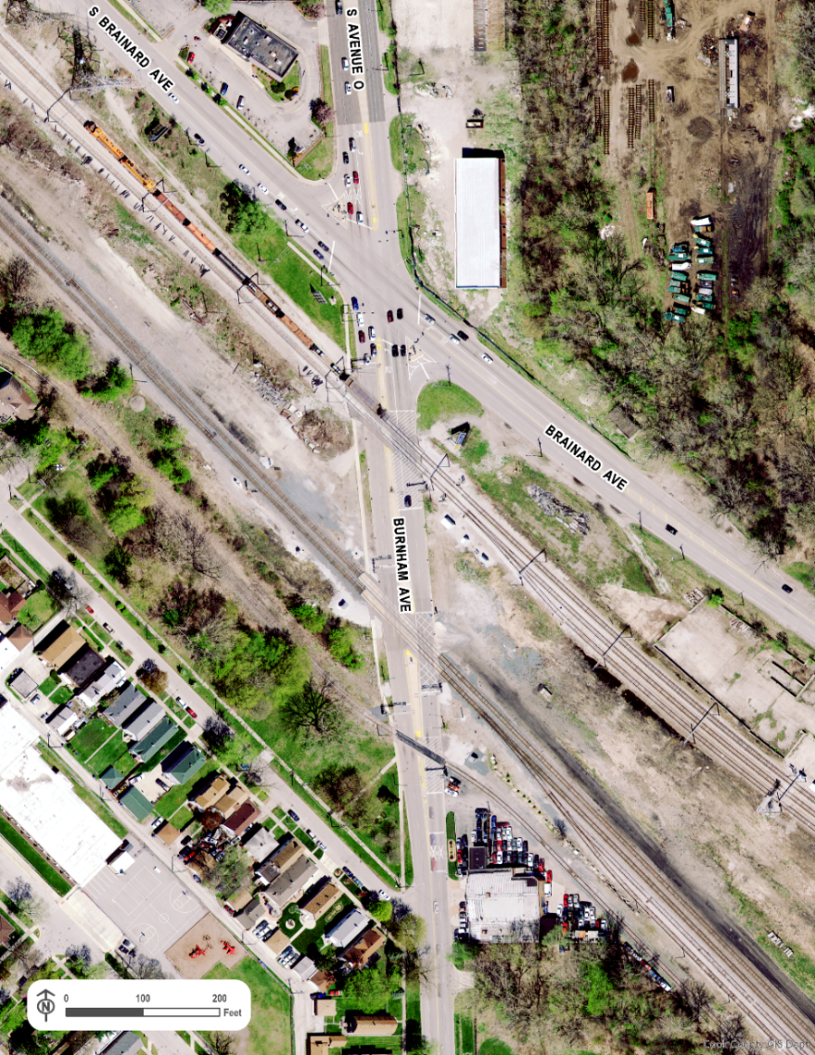
The crossing is closed due to train traffic for more than three (3) hours per day, with nearly 60 closings per day. Around 6 closings per day are closed for 10 minutes or longer. On average, there is a closing of more than 30 minutes every other day. Most of the longest crossing closures occur during the day, 6:00 A.M. to 8:00 P.M. With the length and frequency of the closures, this project will reduce roadway, pedestrian, and bicycle delay and greatly improve safety at this location.

